DEPARTMENT OF INFORMATION SCIENCE AND ENGINEERING
Date | 26 November 2024 | Maximum Marks | 60
Course Code | IS353IA | Duration | 120 min
Sem | V | CIE-1
UG/PG | UG | Faculty:
Artificial Intelligence and Machine Learning
<(Common to AIML/CSE/ISE) >

Sl. No. | Quiz Questions | M | L | CO
1 | Justify whether the following sentence(s) hold true or false for Turing test in context AI. Marks are awarded for justification only.  - The Turing Test requires the machine to be able to convincingly simulate human intelligence to pass.  TRUE- The Turing Test, proposed by Alan Turing, evaluates a machine's ability to exhibit behavior indistinguishable from that of a human during a conversation.  - The Turing Test guarantees that a machine that passes it is intelligent.  FALSE- The Turing Test only measures a machine's ability to mimic human-like responses but does not guarantee genuine intelligence or understanding. | 02 | L3 | CO1
2 | The _________ algorithm uses Entropy as a measure for constructing decision trees, while the ___________ algorithm employs the Gini Index for splitting criteria.  ID3, CART | 02 | L1 | CO1
3 | Draw observations from the graph below  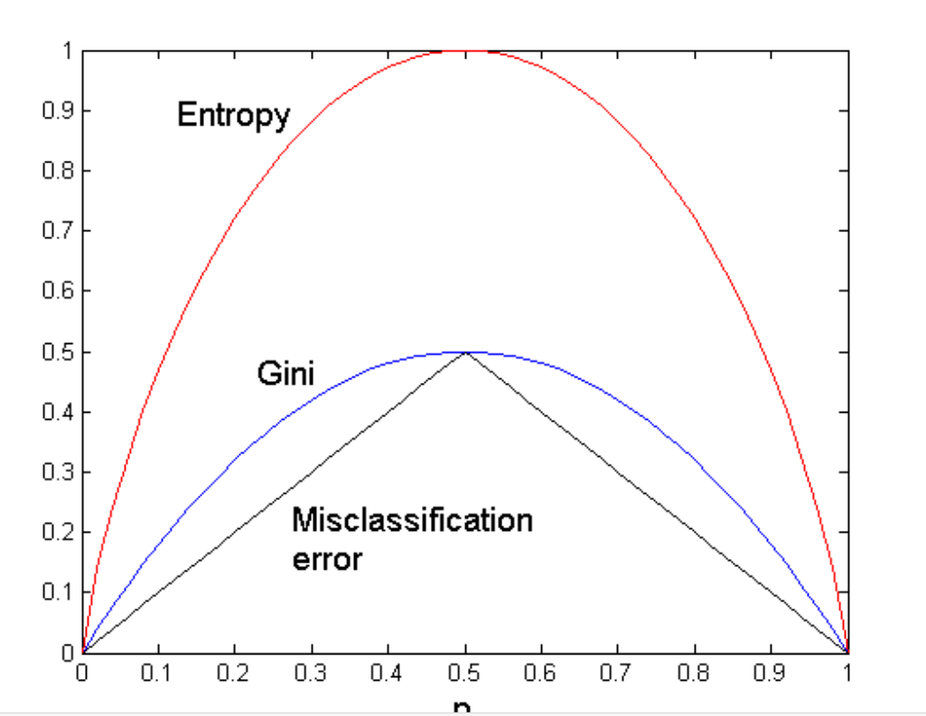  P  - At p=0.5, all measures are at their maximum (highest impurity).  - As p approaches 0 or 1 (classes become more pure), all measures decrease.  - Entropy drops faster than Gini, and Misclassification Error drops the slowest, reflecting their sensitivity to changes in p. | 02 | L3 | CO1
4 | List the key stopping criteria used in constructing a decision tree (any two)  • Maximum depth reached  • No significant information gain  • Pure node (homogeneous labels)  • all attribute same value | 02 | L2 | CO1
5 | Differentiate Rationality and perfection in AI decision making with an example.  Rationality: Making the best decision given the available information, computational limitations, and environmental constraints.  Perfection: Making an ideal decision with complete and perfect information and unlimited computational power. | 02 | L2 | CO1

Sl. No. | Test Questions | M | L | CO
1a | Analyze each of the following agent environments and determine whether they are fully or partially observable, deterministic or stochastic, static or dynamic, and discrete or continuous. Justify your classification with appropriate reasoning for each environment.  - autonomous Mars rover.  - playing tic-tac-toe.  - mathematician's theorem-proving assistant.  2.5*2+3=8M  i. Autonomous Mars Rover  - Observability: Partially Observable (limited sensor range and obstructions).  - Deterministic/Stochastic: Stochastic (unpredictable elements like dust storms).  - Static/Dynamic: Dynamic (environment changes over time).  - Discrete/Continuous: Continuous (real-world terrain and movements).  ii. Playing Tic-Tac-Toe  - Observability: Fully Observable (entire board is visible).  - Deterministic/Stochastic: Deterministic (outcomes depend solely on player moves).  - Static/Dynamic: Static (game state doesn’t change without player action).  - Discrete/Continuous: Discrete (finite moves and board states).  iii. Mathematician's Theorem-Proving Assistant  - Observability: Fully Observable (complete problem description available).  - Deterministic/Stochastic: Deterministic (logical rules ensure predictable outcomes).  - Static/Dynamic: Static (problem doesn’t change during solving).  - Discrete/Continuous: Discrete (steps involve logical, finite reasoning). | 08 | L3 | CO1
1b | For the following examples, find the PEAS (Performance measure, Environment, Actuators, Sensors) framework and describe each component:  - Washing Machine  - Autonomous Drone  - Smart Home Thermostat  2.5*2+3=8M  Example Performance Measure Environment Actuators Sensors  Washing Machine Cleanliness of clothes, minimal water and energy usage, adherence to time settings Laundry load, type of clothes, water supply, detergent Drum motor, water inlet valve, detergent dispenser, heater Water level sensor, temperature sensor, load sensor, speed sensor  Autonomous Drone Safe navigation, task completion (e.g., delivery, surveillance), energy efficiency Airspace, obstacles, GPS location, weather conditions Motors, rotors, camera gimbals, control surfaces GPS, gyroscope, accelerometer, camera, lidar, altimeter  Smart Home Thermostat Maintaining desired temperature with minimal energy consumption Room temperature, external weather, occupancy, HVAC system Heating or cooling system control, fan control Temperature sensor, humidity sensor, occupancy sensor | 06 | L3 | CO1
3a | Consider the following data set:  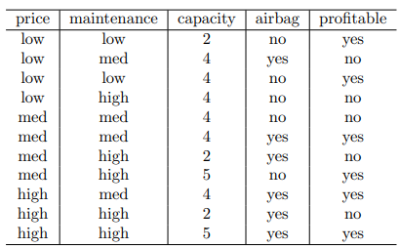  Suppose we decide to construct a decision tree using binary splits and the Gini index impurity measure. Which feature and split point combinations would be the best to use as the root node assuming that we consider each of the input features to be unordered?  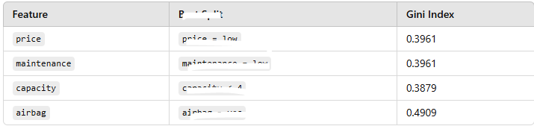  Capacity is best feature | 12 | L3 | CO2
3b | Discuss the approaches for splitting based on continuous attributes? Demonstrate the same using the following dataset: 3+3=6M  Record Age Purchased (Yes/No)  1 22 No  2 25 Yes  3 28 Yes  4 35 No  5 40 Yes  Binary split: 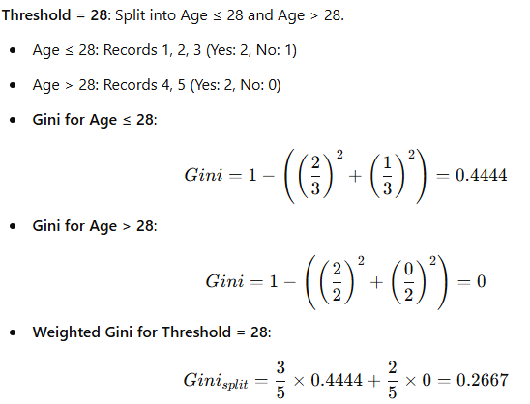  Discrtization approach  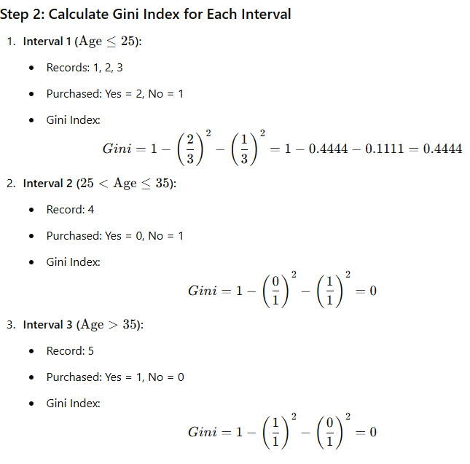 | 06 | L3 | CO2
4a | Compare and contrast the types of intelligent agents—simple reflex, model-based reflex, goal-based, and utility-based—based on their rationality, memory use, ability to handle dynamic or partially observable environments, and computational complexity. Use examples like a robot vacuum or a virtual assistant to illustrate their differences and applications. Present your answer in a tabular format with the following columns: 2*5=10M  Agent Type Rationality Memory Usage Handling Dynamic/Partially Observable Environments Computational Complexity Example/Use Case  Simple Reflex Agent Acts solely based on current percepts without considering history or future; rational in simple tasks Minimal Cannot handle dynamic or partially observable environments effectively Low (simple condition-action rules) Robot vacuum cleaning a static, fully observable room  Model-Based Reflex Agent Rational with the inclusion of an internal model to track the environment state Moderate (needs to store model) Can handle partially observable environments to some extent Moderate (requires model maintenance) Robot vacuum navigating around moving obstacles  Goal-Based Agent Rational by choosing actions aimed at achieving defined goals High (stores model and goals) Can handle dynamic and partially observable environments with goal evaluation High (requires planning and search algorithms) Virtual assistant scheduling appointments based on user goals  Utility-Based Agent Rational by selecting actions that maximize utility or satisfaction Very High (tracks model, goals, and utility) Best suited for complex, dynamic, and partially observable environments Very High (requires optimization algorithms) Self-driving car ensuring safety, efficiency, and passenger comfort | 10 | L3 | CO1
4b | With the help of examples describe the potential causes and solutions of model overfitting in decision trees.  - Overfitting Due to Presence of Noise  - Overfitting Due to Lack of Representative Samples  - High model complexity ( Multiple Comparison Procedure)  2.5*2+3=8M | 08 | L2 | CO1

***********

BT-Blooms Taxonomy, CO-Course Outcomes
Marks Distribution | Particulars |  | CO1 | CO2 | CO3 | CO4 | CO5 | L1 | L2 | L3 | L4 | L5 | L6
 | Test | Max Marks | 42 | 18 |  |  |  | 2 | 12 | 46

Course Outcomes
CO 1 | Explain and apply AI and ML algorithms to address various requirements of real-world problems.
CO 2 | Design and develop AI and ML solutions to benefit society, science, and industry.
CO 3 | Use modern tools to create AI and ML solutions.
CO 4 | Demonstrate effective communication through team presentations and reports to analyze the impact of AI and ML solutions on society and nature.
CO5 | Conduct performance evaluation, modeling, and validation of AI and ML solutions benefiting lifelong learning.

